Website design / build / hosting

Unit 3 Libraries for Python Evidence Collection
Prepared using the live OG Web.site document style and project assets from C:\OGBuild\OG Products\OG Web.site.
Document type | College evidence pack
Learner | Rob Johnston
Unit | Unit 3 - Libraries for Python
Assessment | Assessment 3 - NumPy ndarray Q3 evidence
GitHub account | OG-Website
Brand source | OG Web.site live project templates and assets
This version presents the Unit 3 Assessment 3 NumPy ndarray screenshots, URLs, annotations and practical Jupyter Notebook evidence inside the original OG Web.site branded evidence sheet format.

Screenshot Evidence Collection Document
Learner Name | Rob Johnston
Unit Name | Unit 3 - Libraries for Python
Assessment Name | Assessment 3 - NumPy ndarray Q3 evidence
Tutor/Assessor Name | Mohammad Ali Afgan
GitHub Account | OG-Website
Local Evidence Folder | C:\OGBuild\College\Unit 3 - Libraries for python\Assessment 3 - NumPy ndarray Evidence
Date | 29/06/2026

Document Overview
This evidence collection covers Q3 for Unit 3 Assessment 3. The screenshots show the Jupyter Notebook, NumPy import, ndarray creation, ndarray property checks, saving the ndarray as TXT, CSV and NPY files, confirming saved files, loading the saved files back into Python, and the GitHub URL evidence.
The evidence uses the Assessment 3 NumPy notebook created for Unit 3. It shows NumPy being imported, an ndarray being created, the array properties being checked, the ndarray being saved as TXT, CSV and NPY files, and the saved files being loaded back to prove the process worked.

URL Evidence Section
Area | URL
GitHub evidence folder | https://github.com/OG-Website/L3-Certificate-in-AI-Programming-with-Python/tree/main/unit-3/assessment-3-numpy-ndarray-evidence
GitHub notebook | https://github.com/OG-Website/L3-Certificate-in-AI-Programming-with-Python/blob/main/unit-3/assessment-3-numpy-ndarray-evidence/Assessment%203%20-%20NumPy%20ndarray%20Evidence.ipynb
Local evidence folder | C:\OGBuild\College\Unit 3 - Libraries for python\Assessment 3 - NumPy ndarray Evidence
Local notebook file | C:\OGBuild\College\Unit 3 - Libraries for python\Assessment 3 - NumPy ndarray Evidence\Assessment 3 - NumPy ndarray Evidence.ipynb
Saved ndarray files | og_unit3_scores_ndarray.txt, og_unit3_scores_ndarray.csv, og_unit3_scores_ndarray.npy
Answer text | C:\OGBuild\College\Unit 3 - Libraries for python\Assessment 3 - NumPy ndarray Evidence\Assessment 3 - Answer Text.txt

Assessment Criteria Covered
- Q3. Use the third-party library NumPy to create and save an ndarray.
- 4.1 Create an ndarray using NumPy.
- 4.3 Save an ndarray using NumPy.
- 3.3 Explain the process using comments or markdown cells in Jupyter Notebook.
- Approx. 100 words per screenshot annotation.

NumPy Code Snippet
The notebook creates a two-dimensional ndarray, checks its properties, saves it as TXT, CSV and NPY files, and loads the saved files back to prove the save process worked.
import numpy as np
og_scores = np.array([
[82, 76, 91],
[68, 88, 95]
], dtype=int)
print("Created ndarray:")
print(og_scores)
print("Shape:", og_scores.shape)
print("Dimensions:", og_scores.ndim)
print("Size:", og_scores.size)
print("Data type:", og_scores.dtype)
np.savetxt("og_unit3_scores_ndarray.txt", og_scores, fmt="%d", delimiter=",")
np.savetxt("og_unit3_scores_ndarray.csv", og_scores, fmt="%d", delimiter=",")
np.save("og_unit3_scores_ndarray.npy", og_scores)
loaded_txt = np.loadtxt("og_unit3_scores_ndarray.txt", delimiter=",", dtype=int)
loaded_csv = np.loadtxt("og_unit3_scores_ndarray.csv", delimiter=",", dtype=int)
loaded_npy = np.load("og_unit3_scores_ndarray.npy")

Evidence Table
Reference | Screenshot | Annotation
01 - Notebook open | 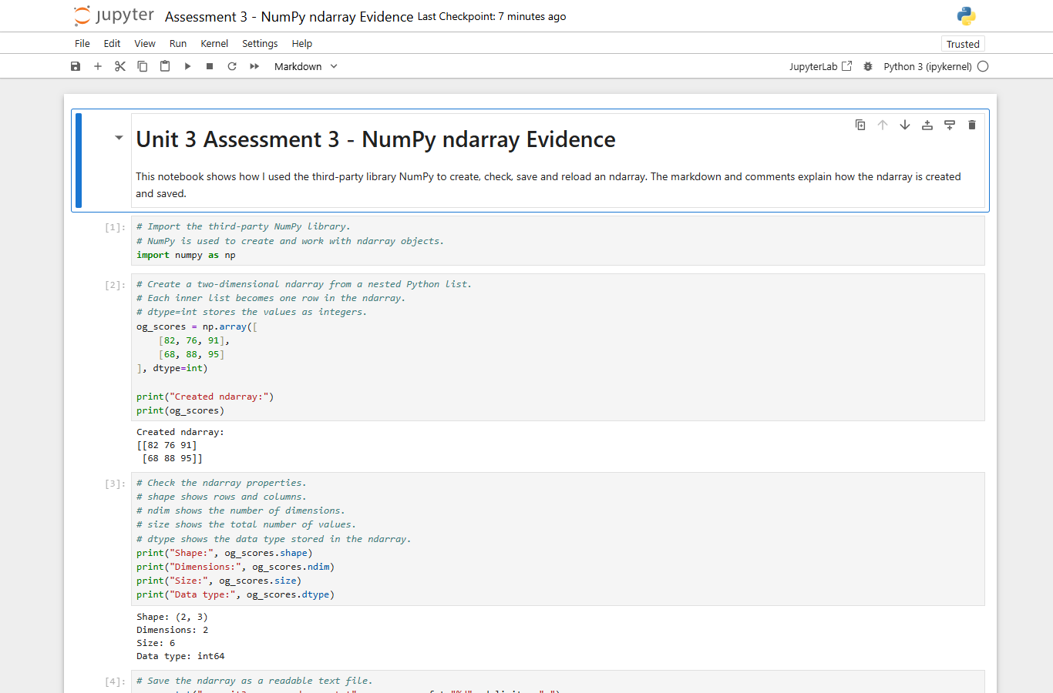 | This screenshot shows the Assessment 3 NumPy ndarray notebook open in Jupyter. It proves that the practical work was completed in a notebook environment, not only described in written answers. The notebook title and markdown heading identify the task as Unit 3 Assessment 3 NumPy ndarray evidence. The introduction explains that the notebook will create, check, save and reload an ndarray. This gives the assessor the source context for the practical evidence and shows that the notebook includes written explanation as well as code cells.
02 - Import NumPy | 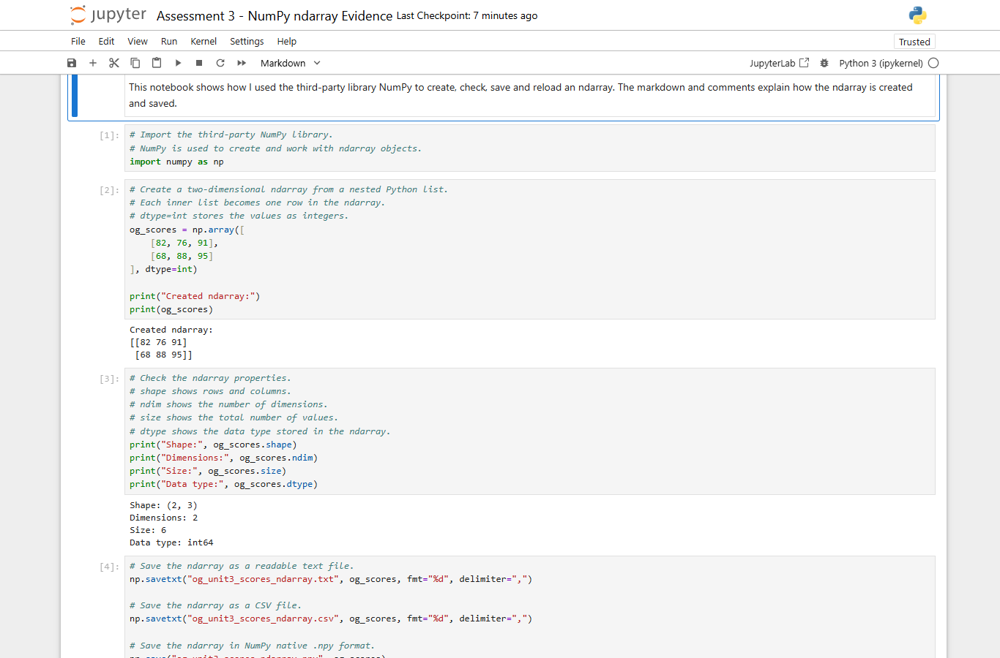 | This screenshot shows NumPy being imported with import numpy as np. The comments explain that NumPy is a third-party Python library and that it is being used to create and work with ndarray objects. This matters because the assessment question specifically asks for the use of a third-party library. The screenshot proves that the later ndarray work is based on NumPy commands, not only standard Python. It also shows that the code is commented clearly inside the notebook, which meets the requirement to explain the work using comments or markdown.
03 - Create ndarray | 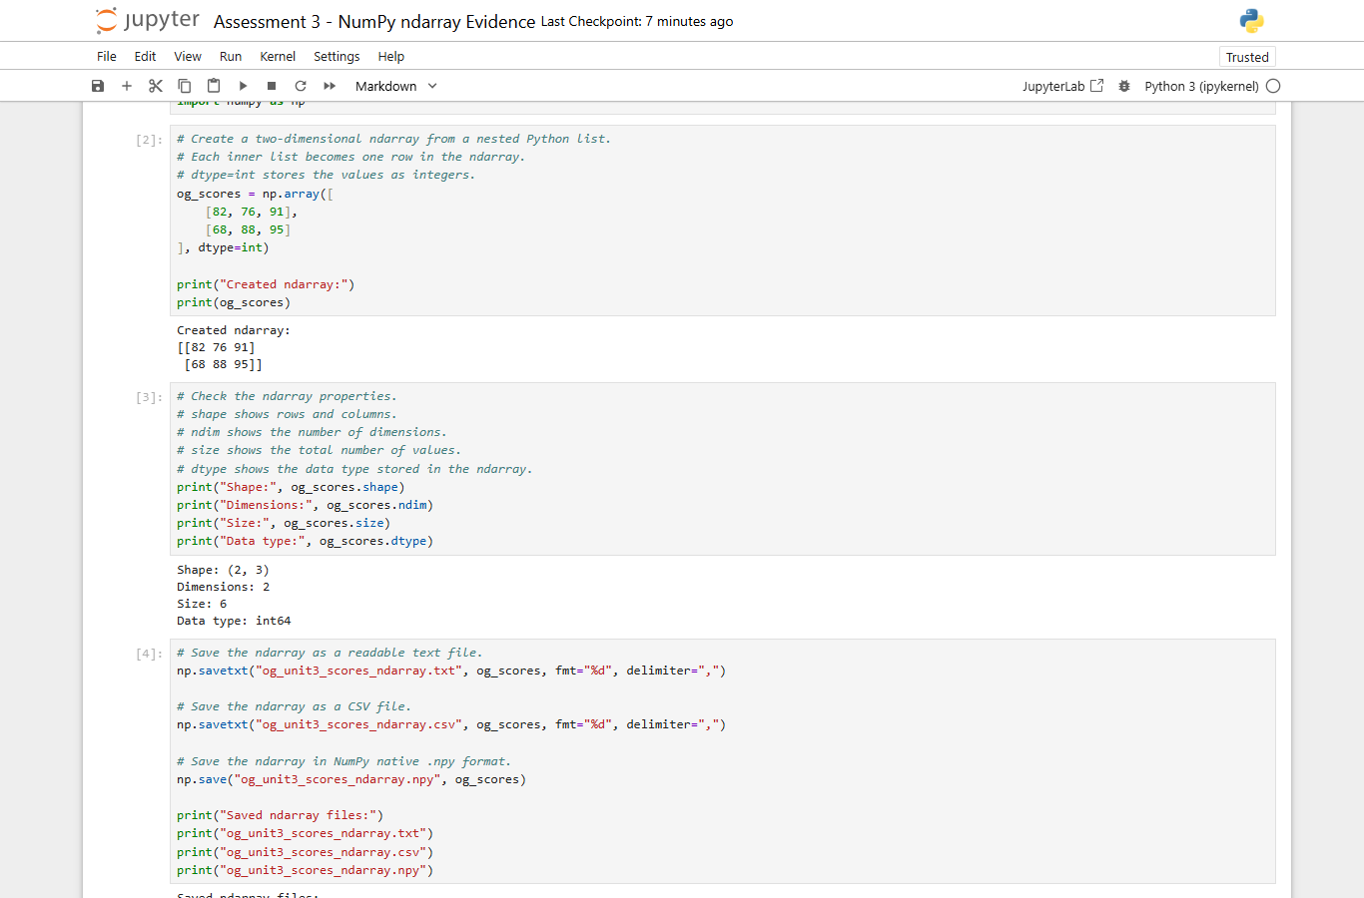 | This screenshot shows the ndarray being created using np.array(). The code uses a nested Python list, where each inner list becomes one row in the two-dimensional ndarray. The dtype=int argument is included so the values are stored as integers. The output underneath the cell prints the created ndarray, proving that the code ran successfully in Jupyter. This screenshot directly supports the create part of the assessment because it shows both the command used to create the ndarray and the resulting array displayed as notebook output.
04 - Check properties | 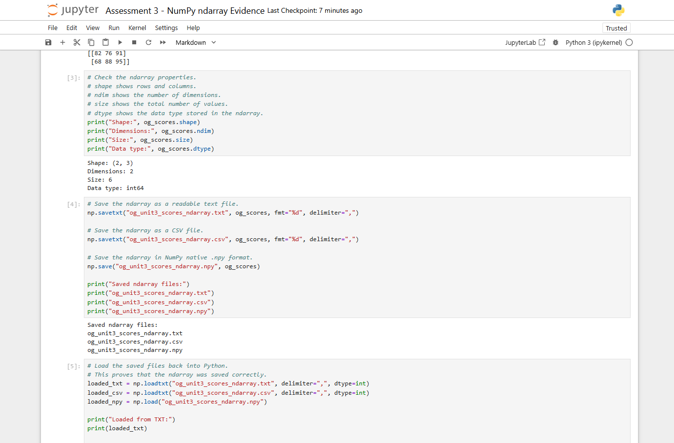 | This screenshot shows the ndarray properties being checked after creation. The notebook prints shape, ndim, size and dtype. Shape proves the row and column structure, ndim confirms that the ndarray is two-dimensional, size shows the total number of values, and dtype shows the data type stored in the array. This is useful because it proves the learner has not only created an ndarray but also understands how to inspect its structure. The comments in the code explain each property, meeting the requirement to explain the process inside the notebook.
05 - Save ndarray | 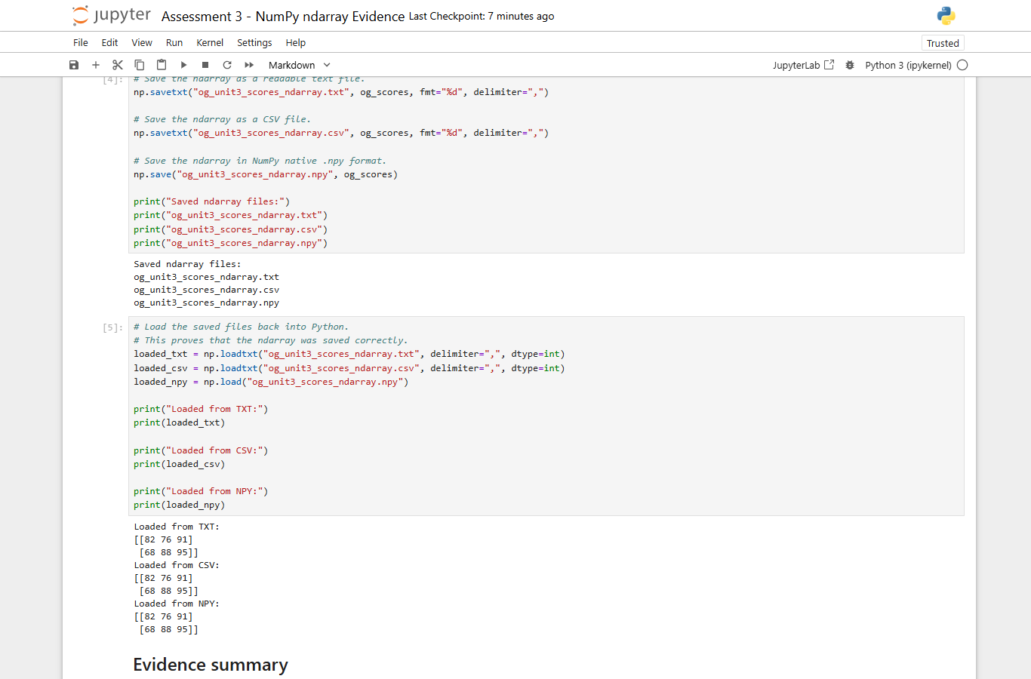 | This screenshot shows the ndarray being saved using NumPy commands. np.savetxt() is used to save readable text and CSV files, while np.save() is used to save the ndarray in NumPy native .npy format. The comments explain why each save method is used. The output lists the saved filenames, which proves that the save commands ran successfully. This screenshot is important because the assessment asks for an ndarray to be created and saved, and this evidence shows the saving stage clearly in the Jupyter notebook.
06 - Saved files visible | 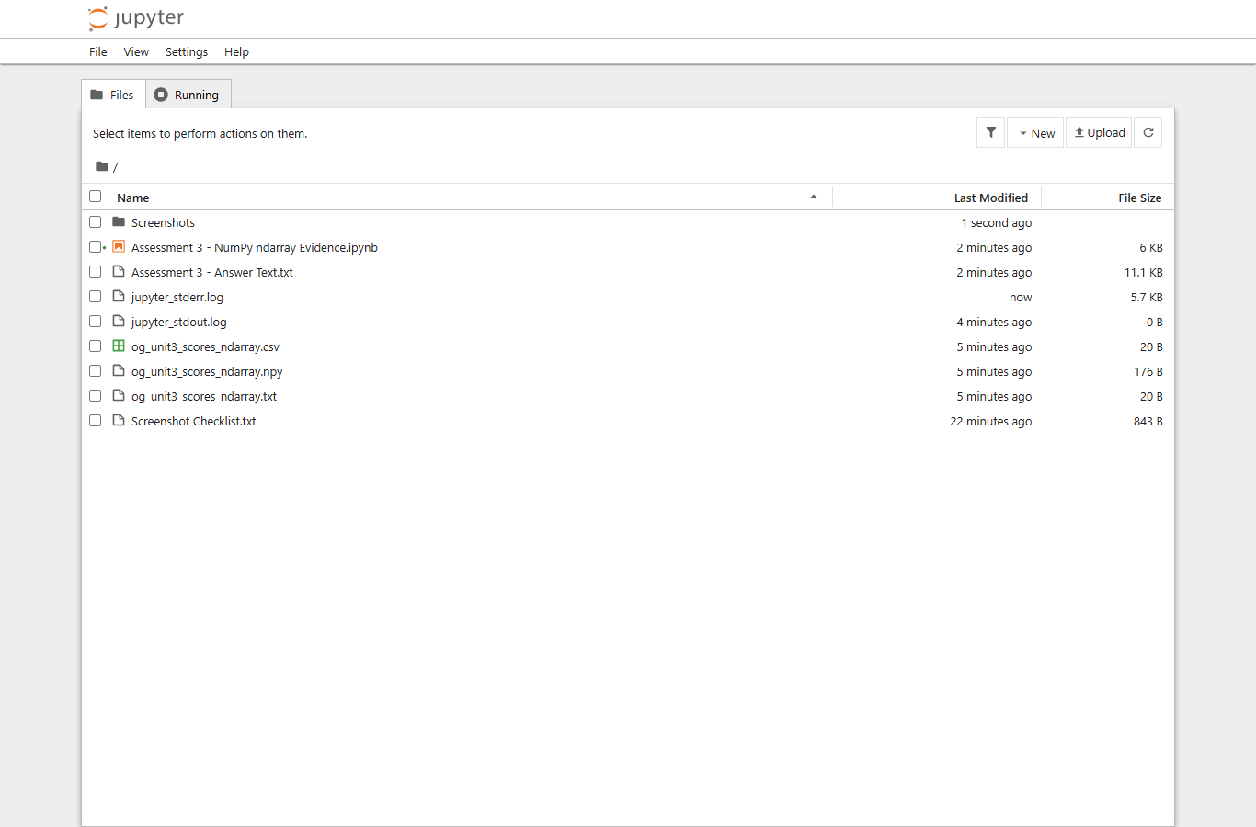 | This screenshot shows the saved ndarray files visible in the Jupyter file browser. The files include og_unit3_scores_ndarray.txt, og_unit3_scores_ndarray.csv and og_unit3_scores_ndarray.npy. This supports the save evidence because it proves that the files were actually created on disk, not just printed in the notebook output. It also shows the notebook and supporting files together in the same Assessment 3 evidence folder. This gives the assessor a clear file trail from the notebook commands to the saved ndarray files.
07 - Load saved ndarray | 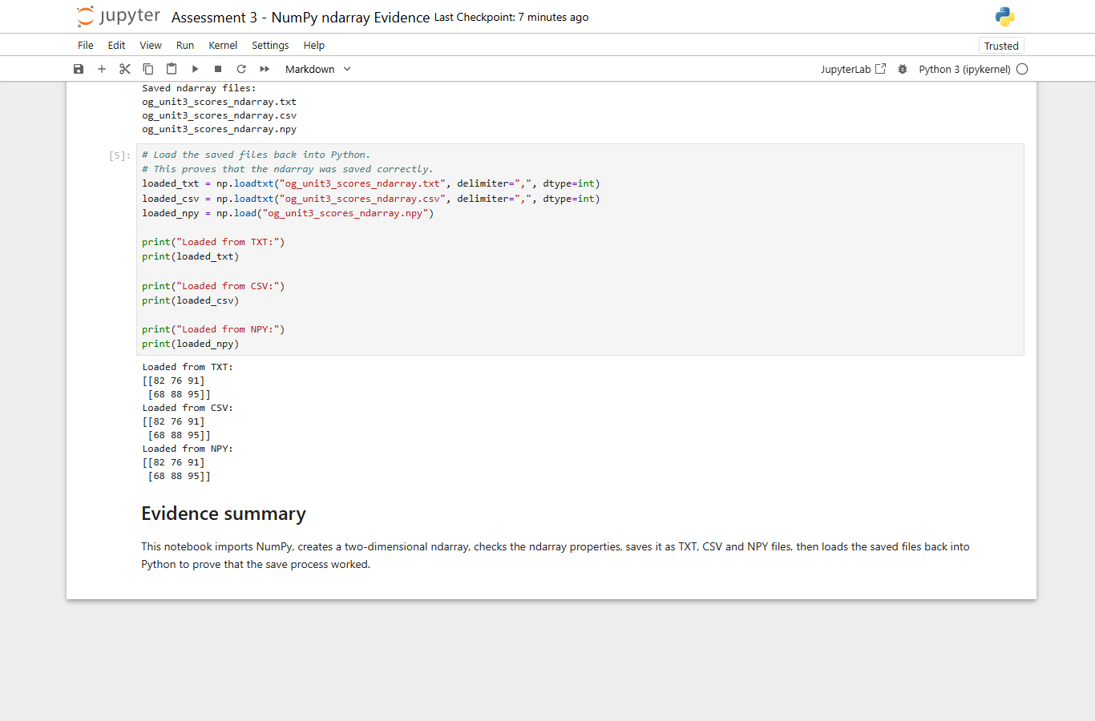 | This screenshot shows the saved ndarray files being loaded back into Python. np.loadtxt() is used for the text and CSV files, and np.load() is used for the NumPy .npy file. The output prints the loaded arrays, proving that the saved files can be reused successfully. This completes the practical evidence chain because the ndarray is created, checked, saved, and then loaded back. It proves that the save process worked correctly and that the saved files are valid NumPy evidence rather than empty or unusable files.
08 - GitHub files URL | 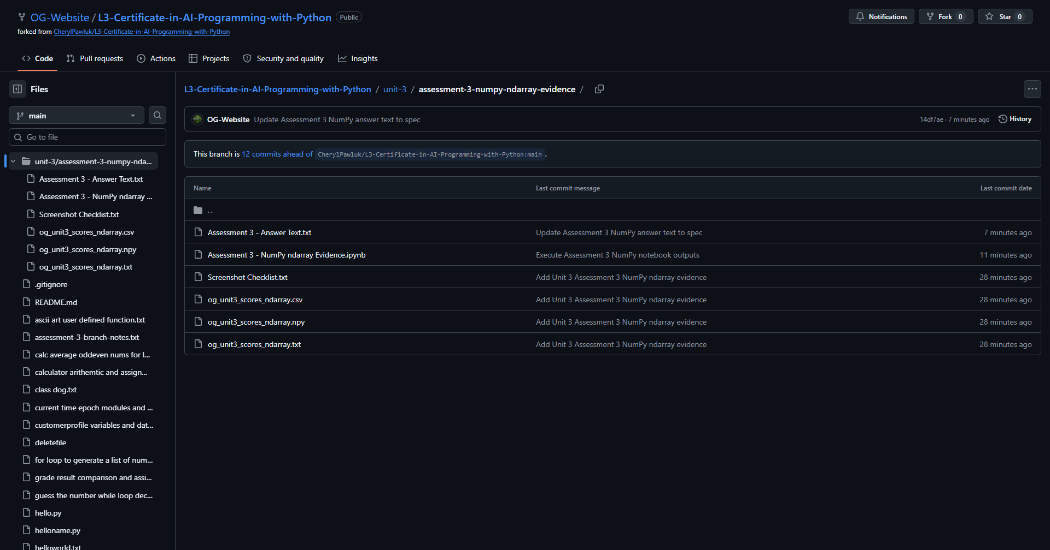 | This screenshot shows the GitHub folder for the Unit 3 Assessment 3 NumPy ndarray evidence. It includes the answer text, notebook, screenshot checklist and saved ndarray files. This gives URL-based evidence that the practical files have been uploaded to the OG-Website GitHub repository. It also proves that the evidence is organised under the correct Unit 3 assessment folder. The GitHub page can be used by the assessor to check the notebook and saved files online, alongside the local screenshots in this evidence pack.
09 - GitHub notebook URL | 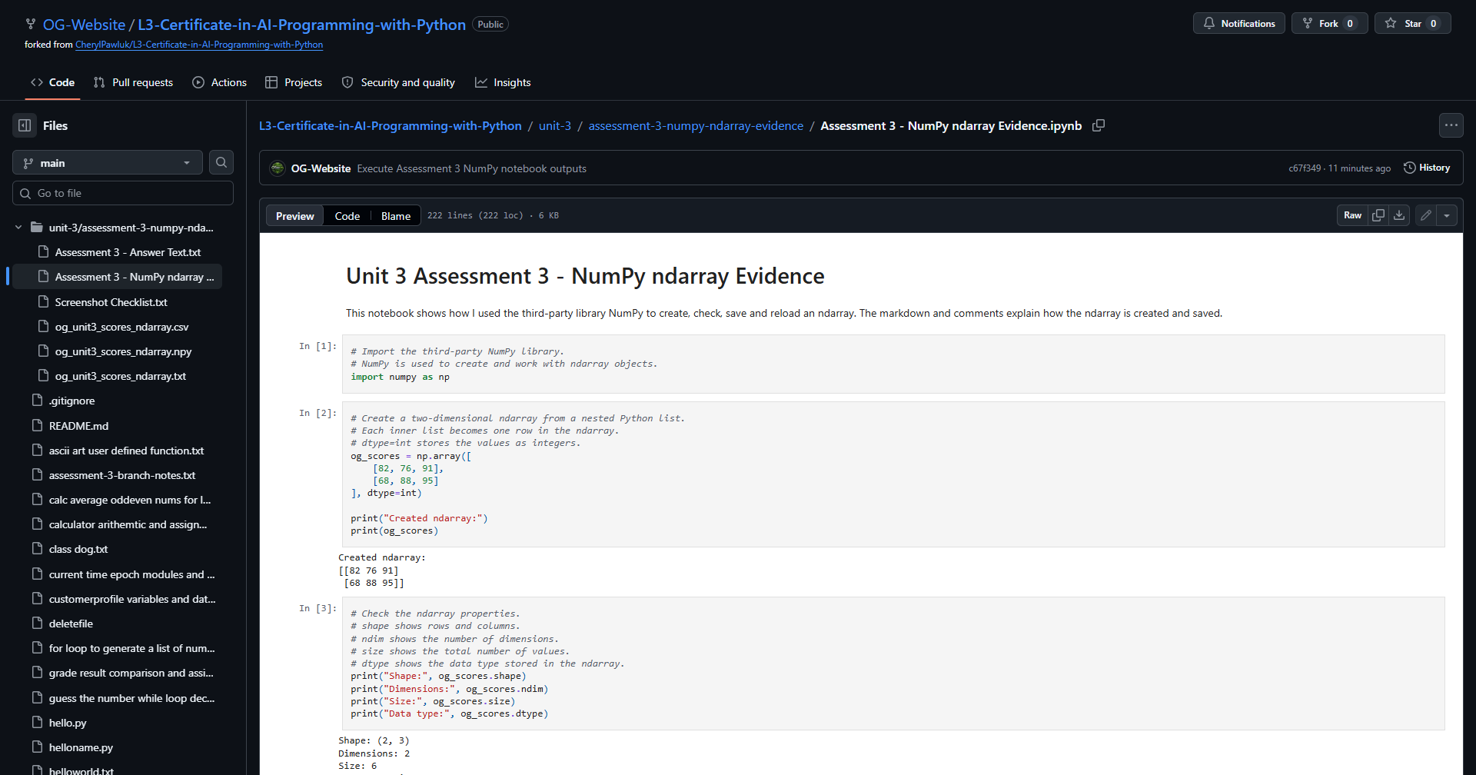 | This screenshot shows the Assessment 3 NumPy ndarray notebook open on GitHub. This is the direct link evidence for the uploaded Jupyter Notebook. It supports the submission requirement because the VLE can receive screenshots, an uploaded notebook, or a URL link to the notebook. The GitHub notebook page shows that the .ipynb file is stored online and can be accessed as part of the submitted evidence for creating and saving an ndarray with NumPy.

